**Get Current Date and Weather**

Steps to follow: -

1. Create an Instant flow
2. Add Location input to get weather based on location
3. Add action as initialize variable to get current date and time i.e, utcNow()

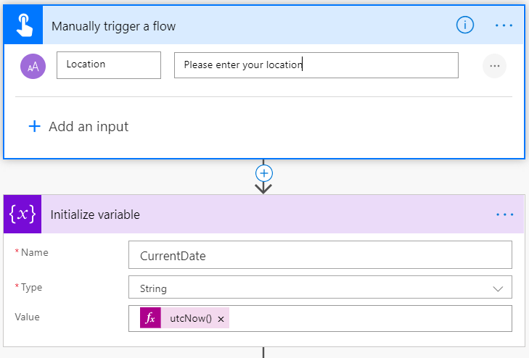

1. Add another variable to create array
2. Add action to get current weather
   1. Create MSN account/login with MSN to get the weather
3. Assign the location

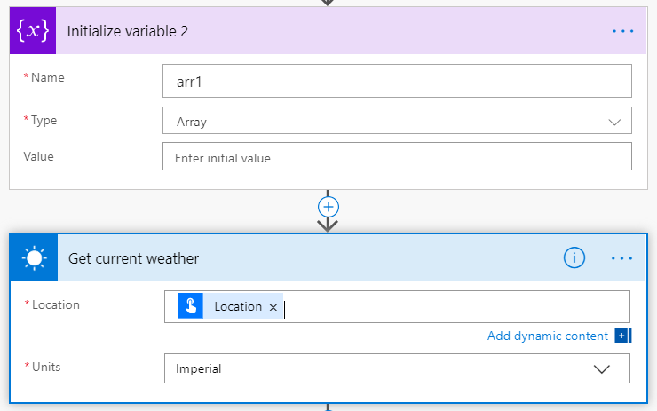

1. Add another action to append to array variable
2. Add temperature, Units and Location

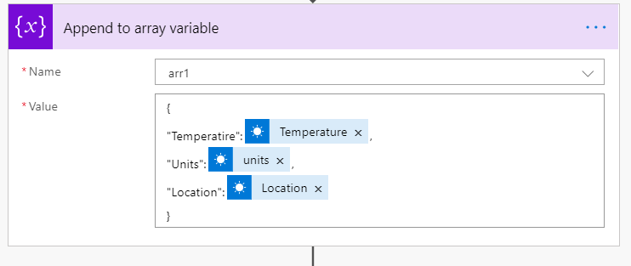

1. Add another action to Convert the array to HTML
2. Add custom Header and value based on your requirement

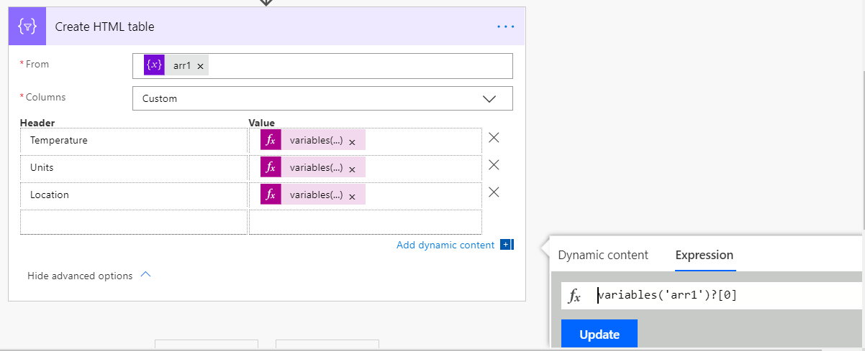

1. Save and test the flow